# Dipika Sharma

# DSC640 T301 Data Presentation & Visualization

# Bellevue University

Table of Contents

Exercise 6.2 3

With Python 3

a) Python - Histogram 3

b) Python – Box Plot 4

c) Python – Bullet Chart 5

d) Python – Scatter Plot 5

With R 6

a) R – Histogram 6

b) R – Box Plot 7

c) R – Bullet Chart 8

d) R – Scatter Plot 9

With Tableau 10

a) Histogram 10

b) Box Plot 11

c) Bullet Chart 12

d) Scatter Plot 13

## Exercise 6.2

### With Python

#### Python - Histogram

#### Python – Box Plot

#### Python – Bullet Chart

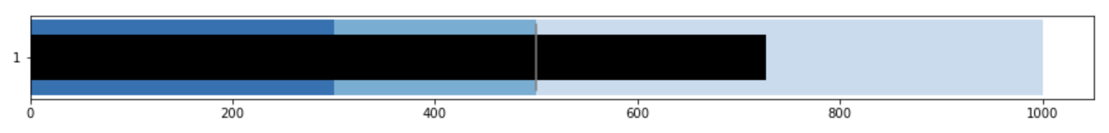

#### Python – Scatter Plot

### With R

#### R – Histogram

#### R – Box Plot

#### R – Bullet Chart

#### R – Scatter Plot

### With Tableau

#### Histogram

#### Box Plot

#### Bullet Chart

#### Scatter Plot

